Concurrency

Definition
# Source: AI Source: Provided by: [Data Path: Persons Table -> ID Column: 1, Name_En Column: Motasem Essam] -> From: [ChatGPT] on [7/25/2026]
Concurrency is a geometric relationship in which three or more geometric objects, usually lines, rays, or line segments extended into lines, pass through or share one common point.
That common point is called the point of concurrency.
For example, if three lines $l_{1}$, $l_{2}$, and $l_{3}$all pass through the same point $P$, then they are concurrent:
$$l_{1}∩l_{2}∩l_{3}=\left\{P\right\}$$
Concurrency is the geometric relationship; the point $P$is the point of concurrency.
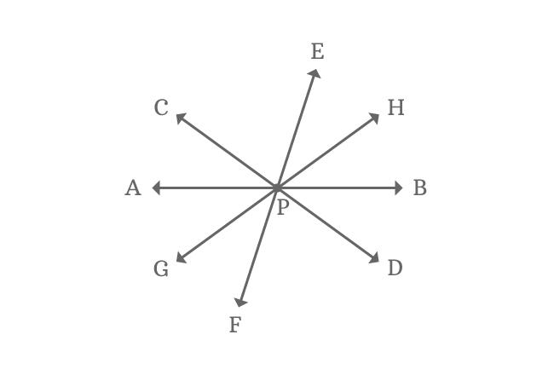
Add to Favorites
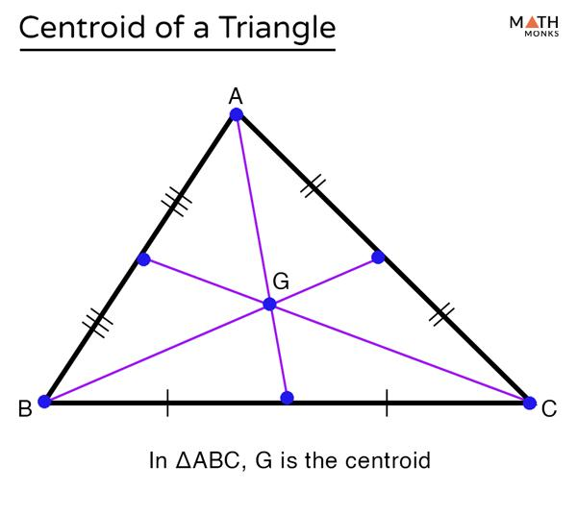
Add to Favorites
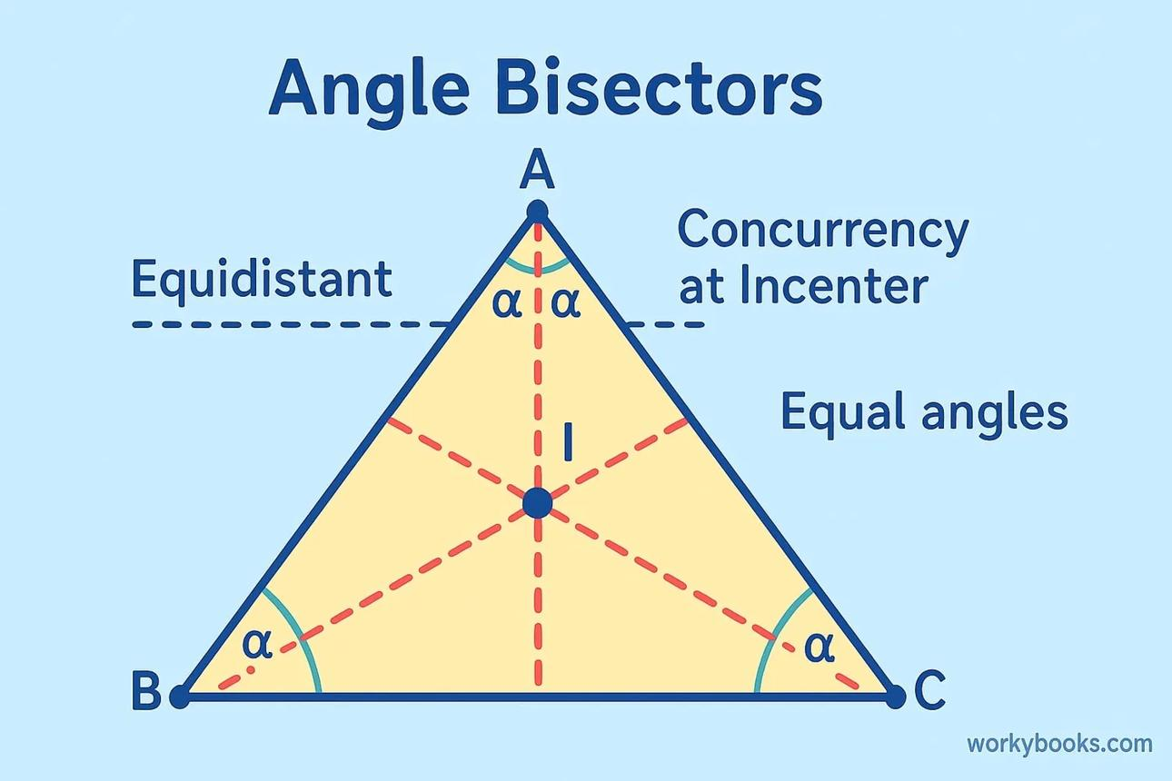
6
Add to Favorites

Purpose
# Source: AI Source: Provided by: [Data Path: Persons Table -> ID Column: 1, Name_En Column: Motasem Essam] -> From: [ChatGPT] on [7/25/2026]
Concurrency is used to:
- Determine whether several lines share a common point.
- Describe the intersection of multiple geometric objects.
- Identify special points in triangles, such as the centroid, incenter, and orthocenter.
- Establish geometric theorems and prove geometric relationships.
- Study geometric constructions and coordinate geometry.
- Analyze the common intersection of lines, rays, and other suitable geometric objects.

Fundamental Concept
# Source: AI Source: Provided by: [Data Path: Persons Table -> ID Column: 1, Name_En Column: Motasem Essam] -> From: [ChatGPT] on [7/25/2026]
The central idea is:
Three or more lines are concurrent if they all pass through one common point.
For three lines $l_{1}$, $l_{2}$, and $l_{3}$, concurrency at point $P$means:
$$P∈l_{1}, P∈l_{2}, P∈l_{3}$$
Equivalently,
$$l_{1}∩l_{2}∩l_{3}=\left\{P\right\}$$
If the lines do not share a common point, they are nonconcurrent.
In a Euclidean plane, two distinct intersecting lines always meet at one point, but three or more lines do not necessarily share the same point.

Types of Concurrency
# Source: AI Source: Provided by: [Data Path: Persons Table -> ID Column: 1, Name_En Column: Motasem Essam] -> From: [ChatGPT] on [7/25/2026]
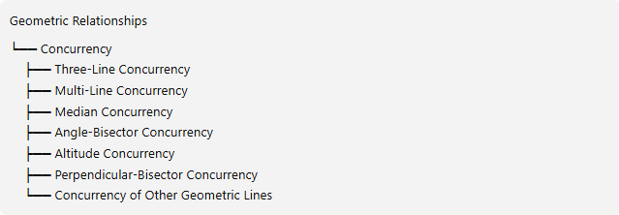
Geometric Relationships
└── Concurrency
├── Three-Line Concurrency
├── Multi-Line Concurrency
├── Median Concurrency
├── Angle-Bisector Concurrency
├── Altitude Concurrency
├── Perpendicular-Bisector Concurrency
└── Concurrency of Other Geometric Lines
These categories describe common configurations and applications of concurrency rather than an exhaustive formal classification.

1. Three-Line Concurrency
# Source: AI Source: Provided by: [Data Path: Persons Table -> ID Column: 1, Name_En Column: Motasem Essam] -> From: [ChatGPT] on [7/25/2026]
Three lines are concurrent when they all pass through the same point.
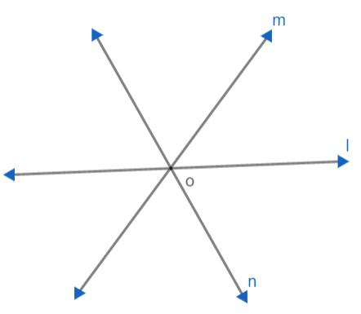
Example:
$$l_{1}∩l_{2}∩l_{3}=\left\{P\right\}$$
All three lines share the common point $P$.

2. Multi-Line Concurrency
# Source: AI Source: Provided by: [Data Path: Persons Table -> ID Column: 1, Name_En Column: Motasem Essam] -> From: [ChatGPT] on [7/25/2026]
Four or more lines may also be concurrent if they share a common point.
For example, if four lines $l_{1},l_{2},l_{3},l_{4}$all pass through $P$, then
$$l_{1}∩l_{2}∩l_{3}∩l_{4}=\left\{P\right\}$$
There is no theoretical upper limit on the number of distinct lines that can pass through one point in a plane.

3. Median Concurrency
# Source: AI Source: Provided by: [Data Path: Persons Table -> ID Column: 1, Name_En Column: Motasem Essam] -> From: [ChatGPT] on [7/25/2026]
The three medians of a triangle are concurrent at a point called the centroid.
A median connects a vertex of a triangle to the midpoint of the opposite side.
For triangle $ABC$, if its three medians meet at $G$, then $G$is the centroid.
The centroid divides each median in the ratio
$$AG:GD=2:1$$
where $D$is the midpoint of $BC$and $G$lies between $A$and $D$.

4. Angle-Bisector Concurrency
# Source: AI Source: Provided by: [Data Path: Persons Table -> ID Column: 1, Name_En Column: Motasem Essam] -> From: [ChatGPT] on [7/25/2026]
The three internal angle bisectors of a triangle are concurrent at the incenter.
The incenter is the center of the triangle's inscribed circle, called the incircle.
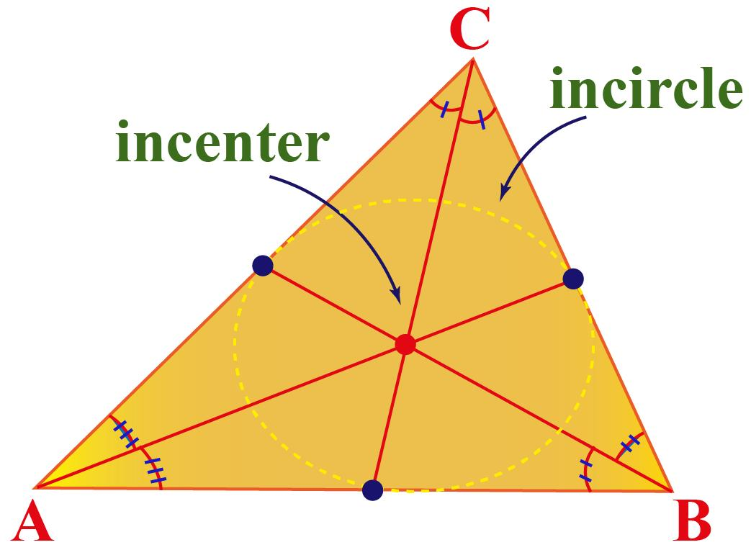
If the angle bisectors meet at $I$, then
$$I∈b_{A}, I∈b_{B}, I∈b_{C}$$
where $b_{A},b_{B},b_{C}$denote the three internal angle-bisector lines.

5. Altitude Concurrency
# Source: AI Source: Provided by: [Data Path: Persons Table -> ID Column: 1, Name_En Column: Motasem Essam] -> From: [ChatGPT] on [7/25/2026]
The three altitudes of a triangle are concurrent at the orthocenter.
An altitude is a line through a vertex perpendicular to the line containing the opposite side.
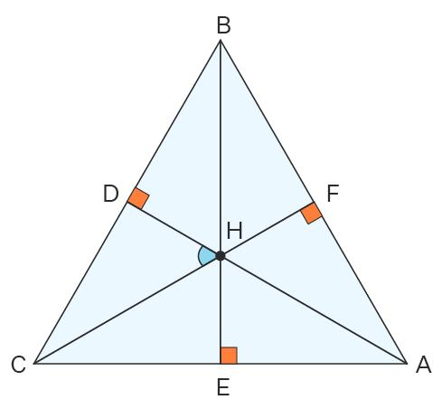
The orthocenter is commonly denoted by $H$.
- Acute triangle: $H$lies inside the triangle.
- Right triangle: $H$is at the right-angle vertex.
- Obtuse triangle: $H$lies outside the triangle.

6. Perpendicular-Bisector Concurrency
# Source: AI Source: Provided by: [Data Path: Persons Table -> ID Column: 1, Name_En Column: Motasem Essam] -> From: [ChatGPT] on [7/25/2026]
The three perpendicular bisectors of a triangle's sides are concurrent at the circumcenter.
A perpendicular bisector passes through a segment's midpoint and is perpendicular to its supporting line.
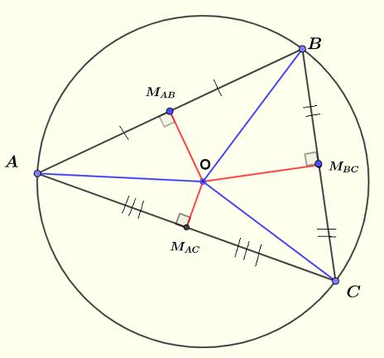
The circumcenter is equidistant from all three vertices:
$$OA=OB=OC$$
It is the center of the triangle's circumscribed circle.

7. Concurrency of Other Geometric Lines
# Source: AI Source: Provided by: [Data Path: Persons Table -> ID Column: 1, Name_En Column: Motasem Essam] -> From: [ChatGPT] on [7/25/2026]
Concurrency also occurs outside the four standard triangle-center constructions. For example:
- Lines in geometric constructions may meet at one designated point.
- Several diagonals or connecting lines may share a common point.
- Lines in projective geometry may be concurrent at a finite point or, in projective settings, at a point at infinity.

Mathematical Tests for Concurrency

1. Intersection Test
# Source: AI Source: Provided by: [Data Path: Persons Table -> ID Column: 1, Name_En Column: Motasem Essam] -> From: [ChatGPT] on [7/25/2026]
For three lines, find the intersection of the first two lines. Then check whether the third line passes through that same point.
Suppose:
$$l_{1}:y=x$$
$$l_{2}:y=-x+4$$
$$l_{3}:y=2$$
First, find the intersection of $l_{1}$and $l_{2}$:
$$x=-x+4$$
$$2x=4⇒x=2$$
Therefore, $y=2$, and the intersection is $P=\left(2 , 2\right)$.
Since $P$also satisfies $l_{3}:y=2$, the three lines are concurrent at $P$.

2. Determinant Test
# Source: AI Source: Provided by: [Data Path: Persons Table -> ID Column: 1, Name_En Column: Motasem Essam] -> From: [ChatGPT] on [7/25/2026]
For three lines written as
$$a_{1}x+b_{1}y+c_{1}=0$$
$$a_{2}x+b_{2}y+c_{2}=0$$
$$a_{3}x+b_{3}y+c_{3}=0$$
a necessary and sufficient condition for the three lines to have a common point in the projective plane is
$$\boxed{∣\begin{matrix}a_{1} & b_{1} & c_{1} \\ a_{2} & b_{2} & c_{2} \\ a_{3} & b_{3} & c_{3}\end{matrix}∣=0}$$
For concurrency at an ordinary finite point in the Euclidean plane, also check that the lines actually share a finite intersection. The determinant condition alone can include parallel lines meeting at a projective point at infinity.

Concurrency vs. Nonconcurrency
# Source: AI Source: Provided by: [Data Path: Persons Table -> ID Column: 1, Name_En Column: Motasem Essam] -> From: [ChatGPT] on [7/25/2026]
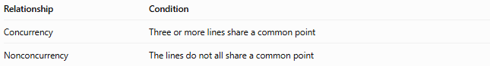
Relationship | Condition
Concurrency | Three or more lines share a common point
Nonconcurrency | The lines do not all share a common point
For example, the lines $y=0$, $x=0$, and $x=2$are nonconcurrent in the Euclidean plane: the first two meet at $\left(0 , 0\right)$, which does not lie on $x=2$.

Concurrency vs. Related Geometric Relationships
# Source: AI Source: Provided by: [Data Path: Persons Table -> ID Column: 1, Name_En Column: Motasem Essam] -> From: [ChatGPT] on [7/25/2026]
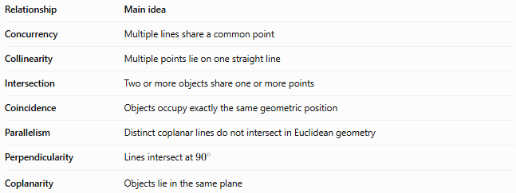
Relationship | Main idea
Concurrency | Multiple lines share a common point
Collinearity | Multiple points lie on one straight line
Intersection | Two or more objects share one or more points
Coincidence | Objects occupy exactly the same geometric position
Parallelism | Distinct coplanar lines do not intersect in Euclidean geometry
Perpendicularity | Lines intersect at 90∘90^\circ90∘
Coplanarity | Objects lie in the same plane
Important distinction: Collinearity describes the alignment of points, whereas concurrency describes the meeting of lines or similar objects. Concurrency also involves intersection, but ordinary pairwise intersection does not guarantee that all the lines share one common point.

Important Properties
# Source: AI Source: Provided by: [Data Path: Persons Table -> ID Column: 1, Name_En Column: Motasem Essam] -> From: [ChatGPT] on [7/25/2026]
- Any two distinct intersecting lines determine a unique intersection point.
- Three or more lines may or may not be concurrent.
- Concurrent lines do not need to form equal angles.
- The point of concurrency may lie inside or outside a triangle.
- The medians, internal angle bisectors, altitudes, and perpendicular bisectors of a triangle are each concurrent.
- Concurrency is different from collinearity.
- Concurrency can be tested using line intersections, coordinate equations, or determinant methods.

Key Points
# Source: AI Source: Provided by: [Data Path: Persons Table -> ID Column: 1, Name_En Column: Motasem Essam] -> From: [ChatGPT] on [7/25/2026]
- Concurrency = several geometric lines passing through one common point.
- The shared point is the point of concurrency.
- Centroid: concurrency point of the medians.
- Incenter: concurrency point of the internal angle bisectors.
- Orthocenter: concurrency point of the altitudes.
- Circumcenter: concurrency point of the perpendicular bisectors.
- The determinant test is useful for checking the concurrency of three lines.

Conclusion
# Source: AI Source: Provided by: [Data Path: Persons Table -> ID Column: 1, Name_En Column: Motasem Essam] -> From: [ChatGPT] on [7/25/2026]
Concurrency is a fundamental geometric relationship that describes when three or more lines share a common point. It is essential in triangle geometry, geometric constructions, coordinate geometry, and the study of special geometric centers.

